**MongDB Lab Assignments –Day 1**

**Q. Exercise is Mongo shell**

**-- Use database named mongo_practice**



**Qn. Insert Documents.**

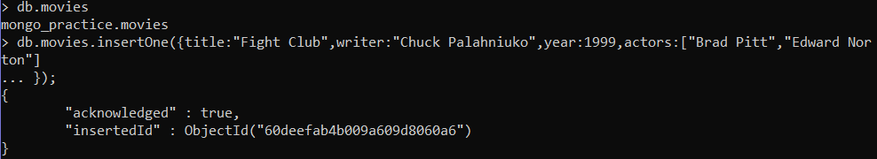

**Query/Find Documents**

**Q1. Show all document**

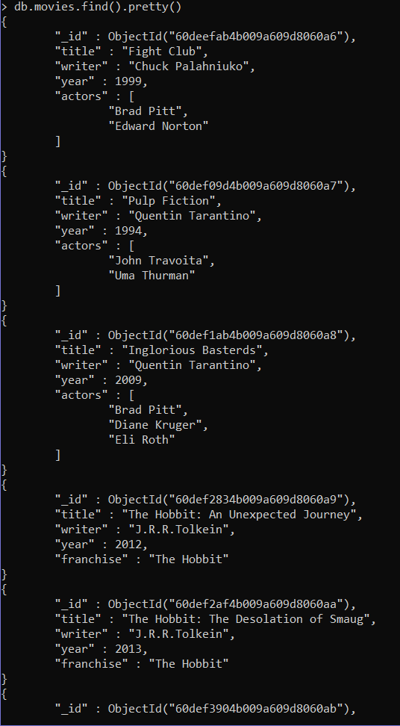

**Q2. > db.movies.find({writer:"Quentin Tarantino"}).pretty()**

**{**

**"_id" : ObjectId("60def09d4b009a609d8060a7"),**

**"title" : "Pulp Fiction",**

**"writer" : "Quentin Tarantino",**

**"year" : 1994,**

**"actors" : [**

**"John Travoita",**

**"Uma Thurman"**

**]**

**},**

**{**

**"_id" : ObjectId("60def1ab4b009a609d8060a8"),**

**"title" : "Inglorious Basterds",**

**"writer" : "Quentin Tarantino",**

**"year" : 2009,**

**"actors" : [**

**"Brad Pitt",**

**"Diane Kruger",**

**"Eli Roth"**

**]**

**}**

**Q3)**

**> db.movies.find({actors:"Brad Pitt"}).pretty()**

**{**

**"_id" : ObjectId("60deefab4b009a609d8060a6"),**

**"title" : "Fight Club",**

**"writer" : "Chuck Palahniuko",**

**"year" : 1999,**

**"actors" : [**

**"Brad Pitt",**

**"Edward Norton"**

**]**

**}**

**{**

**"_id" : ObjectId("60def1ab4b009a609d8060a8"),**

**"title" : "Inglorious Basterds",**

**"writer" : "Quentin Tarantino",**

**"year" : 2009,**

**"actors" : [**

**"Brad Pitt",**

**"Diane Kruger",**

**"Eli Roth"**

**]**

**}**

**>**

**Q4)**

**db.movies.find({franchise:"The Hobbit"}).pretty()**

**{**

**"_id" : ObjectId("60def2834b009a609d8060a9"),**

**"title" : "The Hobbit: An Unexpected Journey",**

**"writer" : "J.R.R.Tolkein",**

**"year" : 2012,**

**"franchise" : "The Hobbit"**

**}**

**{**

**"_id" : ObjectId("60def2af4b009a609d8060aa"),**

**"title" : "The Hobbit: The Desolation of Smaug",**

**"writer" : "J.R.R.Tolkein",**

**"year" : 2013,**

**"franchise" : "The Hobbit"**

**}**

**{**

**"_id" : ObjectId("60def3904b009a609d8060ab"),**

**"title" : "The Hobbit: The Battle of the Five Armies",**

**"writer" : "J.R.R.Tolkein",**

**"year" : 2012,**

**"franchise" : "The Hobbit",**

**"synopsis" : "Bilbo and Company are forced to engage in a war against an array of combatants and keep the Lonely Mountain from falling into the hands of a rising darkness"**

**}**

**>**

**Q5)**

**> db.movies.find({$and:[{year:{$gt:1990}},{year:{$lt:2000}}]}).pretty()**

**{**

**"_id" : ObjectId("60deefab4b009a609d8060a6"),**

**"title" : "Fight Club",**

**"writer" : "Chuck Palahniuko",**

**"year" : 1999,**

**"actors" : [**

**"Brad Pitt",**

**"Edward Norton"**

**]**

**}**

**{**

**"_id" : ObjectId("60def09d4b009a609d8060a7"),**

**"title" : "Pulp Fiction",**

**"writer" : "Quentin Tarantino",**

**"year" : 1994,**

**"actors" : [**

**"John Travoita",**

**"Uma Thurman"**

**]**

**}**

**Q6)**

**> db.movies.find({$or:[{year:{$gt:2010}},{year:{$lt:2000}}]}).pretty()**

**{**

**"_id" : ObjectId("60deefab4b009a609d8060a6"),**

**"title" : "Fight Club",**

**"writer" : "Chuck Palahniuko",**

**"year" : 1999,**

**"actors" : [**

**"Brad Pitt",**

**"Edward Norton"**

**]**

**}**

**{**

**"_id" : ObjectId("60def09d4b009a609d8060a7"),**

**"title" : "Pulp Fiction",**

**"writer" : "Quentin Tarantino",**

**"year" : 1994,**

**"actors" : [**

**"John Travoita",**

**"Uma Thurman"**

**]**

**}**

**{**

**"_id" : ObjectId("60def2834b009a609d8060a9"),**

**"title" : "The Hobbit: An Unexpected Journey",**

**"writer" : "J.R.R.Tolkein",**

**"year" : 2012,**

**"franchise" : "The Hobbit"**

**}**

**{**

**"_id" : ObjectId("60def2af4b009a609d8060aa"),**

**"title" : "The Hobbit: The Desolation of Smaug",**

**"writer" : "J.R.R.Tolkein",**

**"year" : 2013,**

**"franchise" : "The Hobbit"**

**}**

**{ "_id" : ObjectId("60def3904b009a609d8060ab"),**

**"title" : "The Hobbit: The Battle of the Five Armies",**

**"writer" : "J.R.R.Tolkein",**

**"year" : 2012,**

**"franchise" : "The Hobbit",**

**"synopsis" : "Bilbo and Company are forced to engage in a war against an array of combatants and keep the Lonely Mountain from falling into the hands of a rising darkness"**

**}**

**Update Documents**

**Q1) & Q2)**

**> db.movies.update({title:"The Hobbit: The Desolation of Smaug"},{$set:{synopsis:" The dwarves, along with Bilbo Baggins and Gandalf the Grey, continue their quest to reclaim Erebor, their homeland, from Smaug. Bilbo Baggins is in possession of a mysterious and magical ring"}})**

**{ "_id" : ObjectId("60def2834b009a609d8060a9"),**

**"title" : "The Hobbit: An Unexpected Journey",**

**"writer" : "J.R.R.Tolkein",**

**"year" : 2012,**

**"franchise" : "The Hobbit",**

**"synopsis" : "A reluctant hobbit,Bilbo baggins, sets out to the lonely mountain with a spirited group of dwarves to reclaim thei mountain home - and the gold within it - from the dragon Smaug" }**

**{ "_id" : ObjectId("60def2af4b009a609d8060aa"),**

**"title" : "The Hobbit: The Desolation of Smaug",**

**"writer" : "J.R.R.Tolkein",**

**"year" : 2013,**

**"franchise" : "The Hobbit",**

**"synopsis" : " The dwarves, along with Bilbo Baggins and Gandalf the Grey, continue their quest to reclaim Erebor, their homeland, from Smaug. Bilbo Baggins is in possession of a mysterious and magical ring" }**

**Q3) db.movies.update({title: "Pulp Fiction"},{$push:{actors:' Samuel L. Jackson'}}); WriteResult({ "nMatched" : 1, "nUpserted" : 0, "nModified" : 1 })**

**> db.movies.find().pretty()**

**Text Search**

**Q1)**

**> db.movies.find({$text:{$search:'Bilbo'}}).pretty()**

**{**

**"_id" : ObjectId("60def2af4b009a609d8060aa"),**

**"title" : "The Hobbit: The Desolation of Smaug",**

**"writer" : "J.R.R.Tolkein",**

**"year" : 2013,**

**"franchise" : "The Hobbit",**

**"synopsis" : " The dwarves, along with Bilbo Baggins and Gandalf the Grey, continue their quest to reclaim Erebor, their homeland, from Smaug. Bilbo Baggins is in possession of a mysterious and magical ring"**

**}**

**{**

**"_id" : ObjectId("60def3904b009a609d8060ab"),**

**"title" : "The Hobbit: The Battle of the Five Armies",**

**"writer" : "J.R.R.Tolkein",**

**"year" : 2012,**

**"franchise" : "The Hobbit",**

**"synopsis" : "Bilbo and Company are forced to engage in a war against an array of combatants and keep the Lonely Mountain from falling into the hands of a rising darkness"**

**}**

**{**

**"_id" : ObjectId("60def2834b009a609d8060a9"),**

**"title" : "The Hobbit: An Unexpected Journey",**

**"writer" : "J.R.R.Tolkein",**

**"year" : 2012,**

**"franchise" : "The Hobbit",**

**"synopsis" : "A reluctant hobbit,Bilbo baggins, sets out to the lonely mountain with a spirited group of dwarves to reclaim thei mountain home - and the gold within it - from the dragon Smaug"**

**Q2)**

**> db.movies.find({$text:{$search:'Bilbo'}}).pretty()**

**{**

**"_id" : ObjectId("60def2af4b009a609d8060aa"),**

**"title" : "The Hobbit: The Desolation of Smaug",**

**"writer" : "J.R.R.Tolkein",**

**"year" : 2013,**

**"franchise" : "The Hobbit",**

**"synopsis" : " The dwarves, along with Bilbo Baggins and Gandalf the Grey, continue their quest to reclaim Erebor, their homeland, from Smaug. Bilbo Baggins is in possession of a mysterious and magical ring"**

**}**

**{**

**"_id" : ObjectId("60def3904b009a609d8060ab"),**

**"title" : "The Hobbit: The Battle of the Five Armies",**

**"writer" : "J.R.R.Tolkein",**

**"year" : 2012,**

**"franchise" : "The Hobbit",**

**"synopsis" : "Bilbo and Company are forced to engage in a war against an array of combatants and keep the Lonely Mountain from falling into the hands of a rising darkness"**

**}**

**{**

**"_id" : ObjectId("60def2834b009a609d8060a9"),**

**"title" : "The Hobbit: An Unexpected Journey",**

**"writer" : "J.R.R.Tolkein",**

**"year" : 2012,**

**"franchise" : "The Hobbit",**

**"synopsis" : "A reluctant hobbit,Bilbo baggins, sets out to the lonely mountain with a spirited group of dwarves to reclaim thei mountain home - and the gold within it - from the dragon Smaug"**

**Q3)**

**db.movies.find({$text:{$search:'Bilbo -Gandalf'}}).pretty()**

**{**

**"_id" : ObjectId("60def3904b009a609d8060ab"),**

**"title" : "The Hobbit: The Battle of the Five Armies",**

**"writer" : "J.R.R.Tolkein",**

**"year" : 2012,**

**"franchise" : "The Hobbit",**

**"synopsis" : "Bilbo and Company are forced to engage in a war against an array of combatants and keep the Lonely Mountain from falling into the hands of a rising darkness" } {**

**"_id" : ObjectId("60def2834b009a609d8060a9"),**

**"title" : "The Hobbit: An Unexpected Journey",**

**"writer" : "J.R.R.Tolkein",**

**"year" : 2012,**

**"franchise" : "The Hobbit",**

**"synopsis" : "A reluctant hobbit,Bilbo baggins, sets out to the lonely mountain with a spirited group of dwarves to reclaim thei mountain home - and the gold within it - from the dragon Smaug" }**

**Q4)**

**db.movies.find({$text:{$search:'dwarves hobbit'}}).pretty()**

**{**

**"_id" : ObjectId("60def2af4b009a609d8060aa"),**

**"title" : "The Hobbit: The Desolation of Smaug",**

**"writer" : "J.R.R.Tolkein",**

**"year" : 2013,**

**"franchise" : "The Hobbit",**

**"synopsis" : " The dwarves, along with Bilbo Baggins and Gandalf the Grey, continue their quest to reclaim Erebor, their homeland, from Smaug. Bilbo Baggins is in possession of a mysterious and magical ring"**

**}**

**{**

**"_id" : ObjectId("60def2834b009a609d8060a9"),**

**"title" : "The Hobbit: An Unexpected Journey",**

**"writer" : "J.R.R.Tolkein",**

**"year" : 2012,**

**"franchise" : "The Hobbit",**

**"synopsis" : "A reluctant hobbit,Bilbo baggins, sets out to the lonely mountain with a spirited group of dwarves to reclaim thei mountain home - and the gold within it - from the dragon Smaug"**

**}**

**Q5)**

**> db.movies.find({$text:{$search:'gold dragon'}}).pretty()**

**{**

**"_id" : ObjectId("60def2834b009a609d8060a9"),**

**"title" : "The Hobbit: An Unexpected Journey",**

**"writer" : "J.R.R.Tolkein",**

**"year" : 2012,**

**"franchise" : "The Hobbit",**

**"synopsis" : "A reluctant hobbit,Bilbo baggins, sets out to the lonely mountain with a spirited group of dwarves to reclaim thei mountain home - and the gold within it - from the dragon Smaug" }**

**Delete Documents**

**Q1)&Q2)**

**> db.movies.find({},{title:1,_id:0}).pretty()**

**{ "title" : "The Hobbit: The Desolation of Smaug" }**

**{ "title" : "The Hobbit: The Battle of the Five Armies" }**

**{ "title" : "The Hobbit: An Unexpected Journey" }**

**{ "title" : "Pulp Fiction" }**

**{ "title" : "Inglorious Basterds" }**

**{ "title" : "Fight Club" }**

**{ "title" : "Pee Wee Herman's Big Adventure" }**

**{ "title" : "Avatar" }**

**> db.movies.remove({title:"Pee Wee Herman's Big Adventure"}) WriteResult({ "nRemoved" : 1 })**

**> db.movies.find({},{title:1,_id:0}).pretty()**

**{ "title" : "The Hobbit: The Desolation of Smaug" }**

**{ "title" : "The Hobbit: The Battle of the Five Armies" }**

**{ "title" : "The Hobbit: An Unexpected Journey" }**

**{ "title" : "Pulp Fiction" }**

**{ "title" : "Inglorious Basterds" }**

**{ "title" : "Fight Club" }**

**{ "title" : "Avatar" }**

**> db.movies.remove({title:"Avatar"})**

**WriteResult({ "nRemoved" : 1 })**

**> db.movies.find({},{title:1,_id:0}).pretty()**

**{ "title" : "The Hobbit: The Desolation of Smaug" }**

**{ "title" : "The Hobbit: The Battle of the Five Armies" }**

**{ "title" : "The Hobbit: An Unexpected Journey" }**

**{ "title" : "Pulp Fiction" }**

**{ "title" : "Inglorious Basterds" }**

**{ "title" : "Fight Club" }**

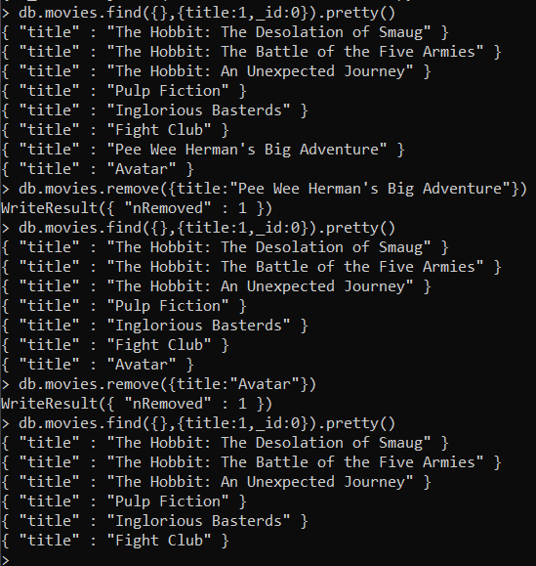

**Relationships**

**User collection**

**> db.user.find().pretty()**

**{**

**"_id" : ObjectId("60df4cc1a681779b79bff739"),**

**"username" : "GoodGuyGreg",**

**"first_name" : "Good Guy",**

**"last_name" : "Greg"**

**}**

**{**

**"_id" : ObjectId("60df4cc1a681779b79bff73a"),**

**"username" : "ScumbagSteve",**

**"full_name" : [**

**{**

**"first" : "Scumbag",**

**"last" : "Steve"**

**}**

**]**

**}**

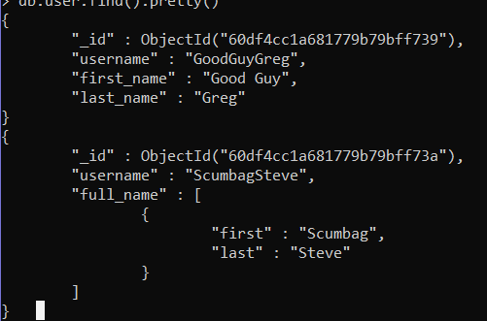

**Documents into a posts collection**

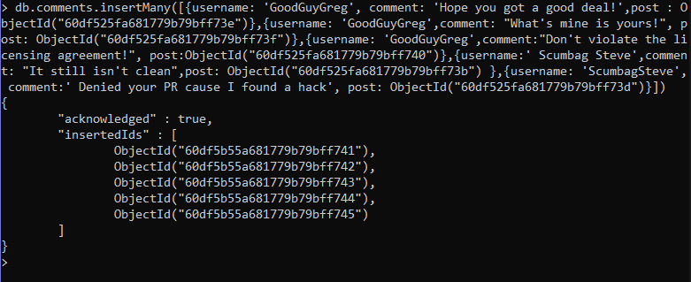

**QUERYING RELATED COLLECTIONS**

**Q1)**

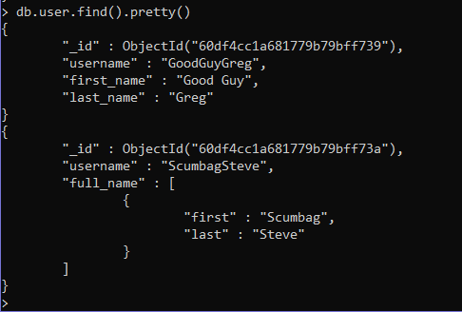

**Q2)**

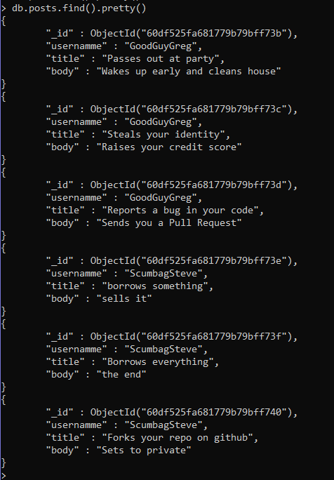

**Q3)**

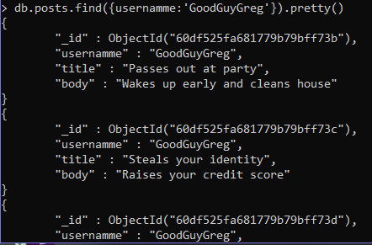

**Q4)**

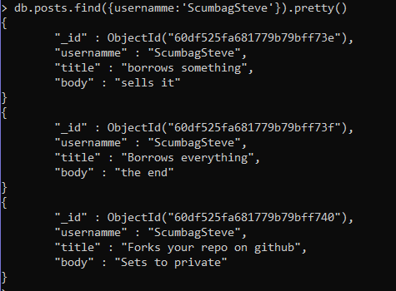

**Q5)**

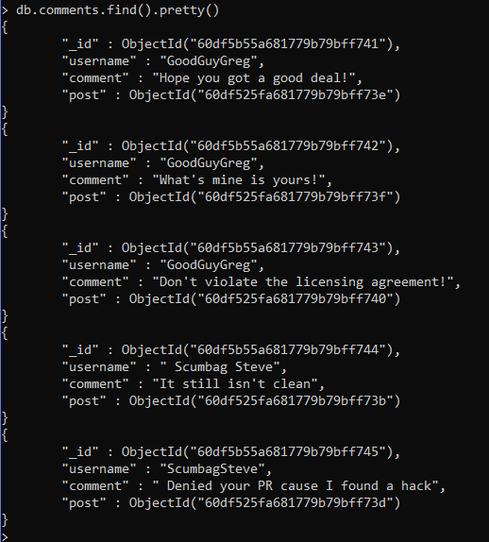

**Q6)**

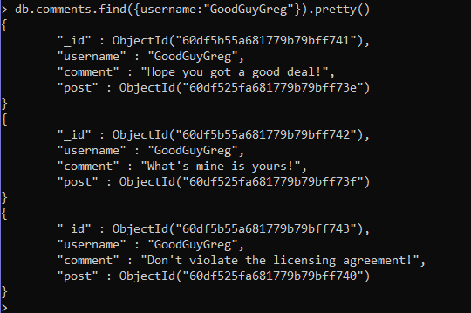

**Q7)**

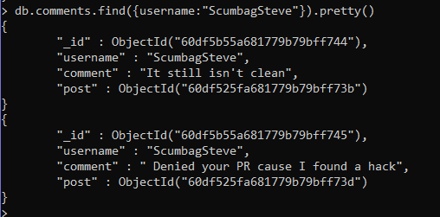

**Q8)**

